Create a program with a graphical user interface that takes in a search string and displays photographs that match the search string. Use Flickr’s public photo feed at <https://www.flickr.com/services/feeds/docs/photos_public/> as your service.

**Sample Output**

Photo search “nature” should display something like below.

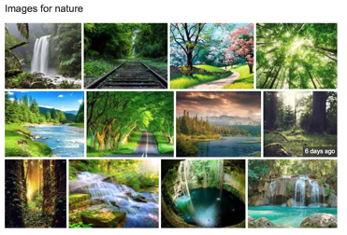

Expectation: [C#]

1. Build a .NET application using public API’s from Flickr.
2. Production ready and bug free application

C++ candidates can use C++ and MFC if they prefer native or can go ahead with C# and WPF.

**Evaluation Criteria**

1      Working application – that looks cleans and works as expected

2      Modularity of design, application of SOLID principles

3      Code elegance – readability, naming conventions.

4      Testability – unit testing, test driven development.